**TimelessKettles UK**

* Desktop / Laptop layout example
  + Landing / Home page

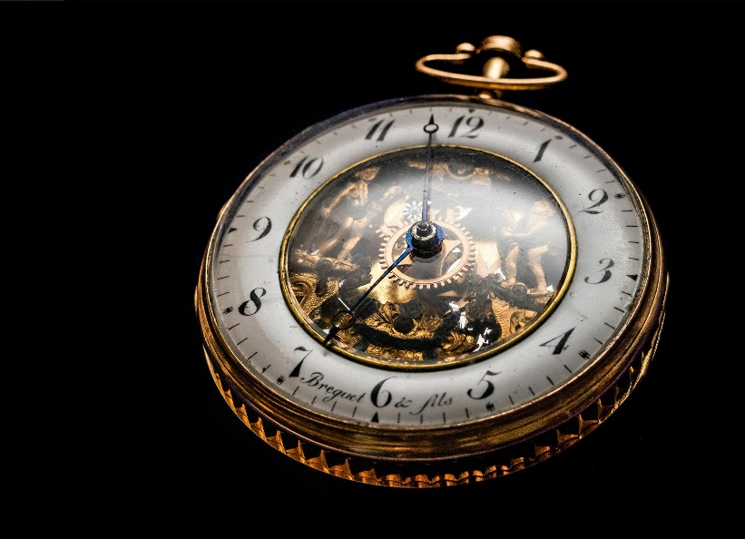

Home About Store Contact us Basket(icon)

Timeless Kettles UK

Est 2023 – London UK

----Example slogan below ----

Footer TK All Rights Reserved © 2024

* + A logo on a white surface

    Description automatically generated Contact us page

Home About Store Contact us Basket(icon)

**Enquiries Form?**

* Name
* Email
* Message

Footer TK All Rights Reserved © 2024

Send Message

* + A logo on a white surface

    Description automatically generatedAbout page

Home About Store Contact us Basket(icon)

(Example text small paragraph explaining the

business role etc) TK Has been selling watches for x time etc etc…

**Sourcing process?**

**(EXAMPLE BOX)**

s

* Name - Date

Bought x watch from Y place. It was amazing etc etc

**Testimonials**

* Name - Date

Bought x watch from Y place. It was amazing etc etc

* Step Three

Sell watch? (Any example text )

* Step Two

Agree price / meet? (Any example text )

* Step one

Find watch? (Any example text )

* + A person wearing a hat

    Description automatically generatedA person wearing a hat

    Description automatically generatedA person wearing a hat

    Description automatically generatedA person wearing a hat

    Description automatically generatedA person wearing a hat

    Description automatically generatedA person wearing a hat

    Description automatically generatedStore page
* Name - Date

Bought x watch from Y place. It was amazing etc etc

Footer TK All Rights Reserved © 2024

Home About Store Contact us Basket(icon)

Sort By: Filter: Results 1 of 20

* Item name
* Price
* Item name
* Price
* Item name
* Price

Footer TK All Rights Reserved © 2024

Item View

Home About Store Contact us Basket(icon)

Add to Cart

* Item name
* Price
* Color (Selection menu)
* Quantity
* Item description

Footer TK All Rights Reserved © 2024